Competitive Shooters of Lake Norman 2025 Club Championship
COURSE DESIGNER: Ike Starnes
START POSITION: See written stage briefings.
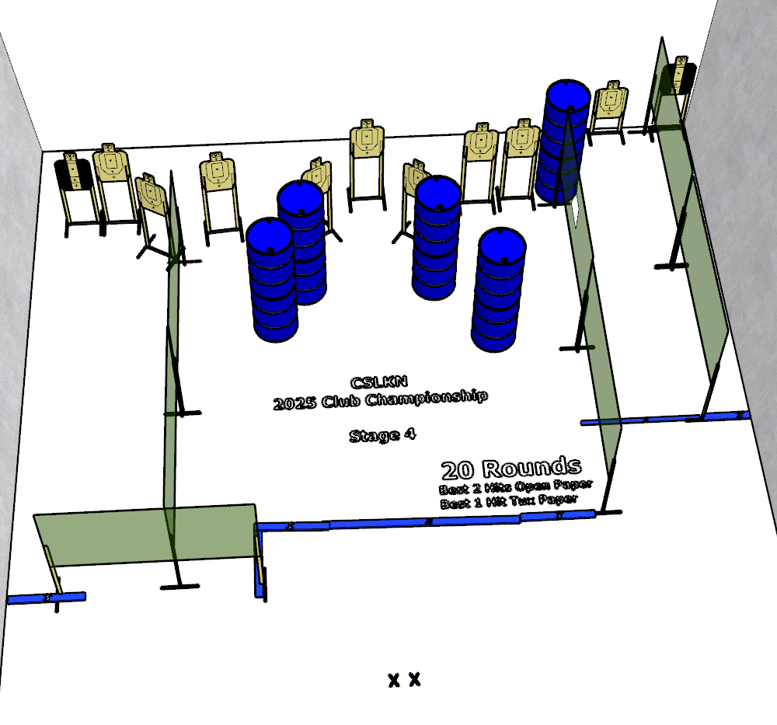

Written Stage Briefing:

Stage 6 - We have both kinds of music, Country.... and Western- is a 20-round, 100 point, Comstock Course. There are 11 cardboard targets and some noshoots. The best 2 hits per static cardboard target will be scored. The best 1 hit per Tux target will be scored.
Handgun start position Both feet on Xs. The handgun is unloaded and holstered.
PCC start position Both feet on Xs. PCC is unloaded with stock touching belt.
On the audible start signal, engage targets from within the shooting area.

